# ABC’s Inventory Management System

## Test Script

|  |  |  |  |  |  |
| --- | --- | --- | --- | --- | --- |
| **Test Name** | | Click on Search button without entering any Product Item Code or Product Code values (Test Case SPT005) | | | |
| **Use Case Tested** | | Search Product | | | |
| **Test Description** | | This test tests the outcome of clicking on the ‘Search’ button without entering any values in the Product Code and Product Item Code field. | | | |
| **Pre-Conditions** | | - | | | |
| **Post-Conditions** | | Appropriate message is displayed. | | | |
| **Notes** | | - | | | |
| **Result (Pass/Fail/Warning/ Incomplete)** | | Pass | | | |
|  | **Test Step** | | **Expected Test Results** | **P** | **F** |
| 1. | Open the ABCInventoryClient.exe file | | ABCInventoryClient system launches. | P |  |
| 2. | Click on ‘Search’ button without entering any values for product code and product item code. | | System displays a message prompting user to enter the product code or the product item code. | P |  |

|  |  |  |  |
| --- | --- | --- | --- |
| **Test Data Table** | | | |
|  | **1** | **2** | **3** |
| **Product Code** | - | - | - |
| **Location ID** | - | - | - |
| **Location Name** | - | - | - |

# Result Screenshots

The screenshots of the result on each test step for the test are as follows:

**Step 1**

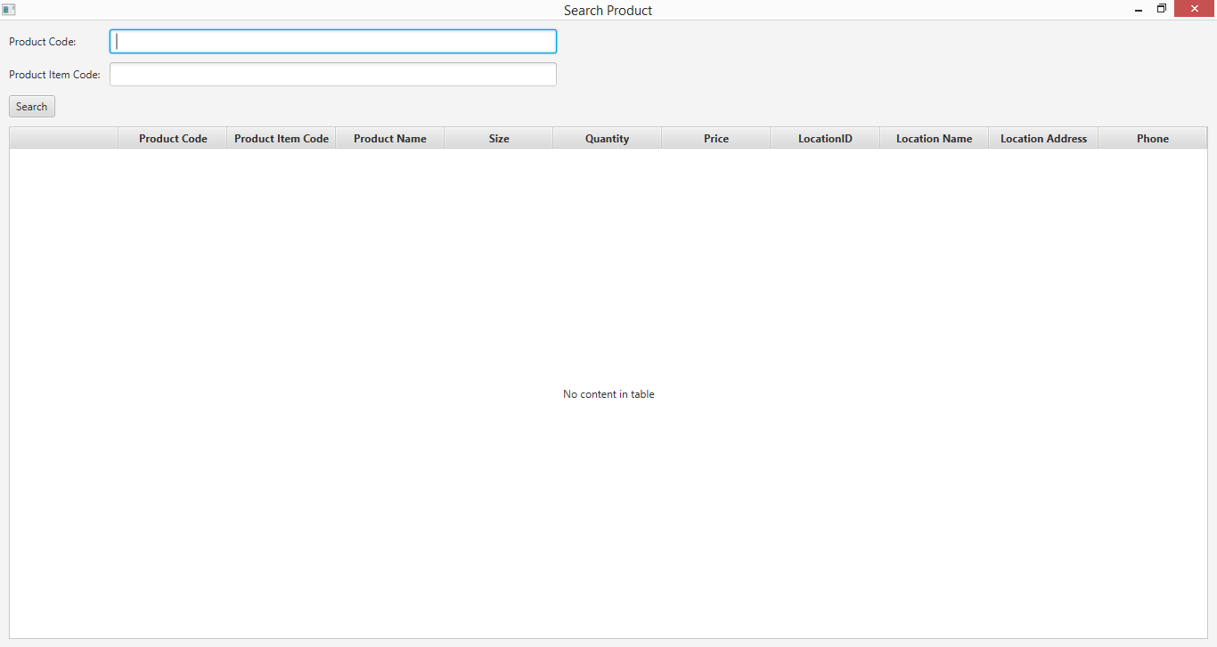

**Step 2**

